ADVENTURE WORKS · TECHNICAL SUPPORT

Pedals Creaking, Loose, or Cleat Problems
Drivetrain Document TS-013 Rev. A
Applies to | All Adventure Works models
Difficulty | Beginner
Time required | 10 – 25 minutes
Tools needed | 8 mm hex key / 15 mm pedal wrench, Hex keys for cleats, Grease, Torque wrench

Symptoms
- A creak or click once per pedal stroke.
- Play felt at the pedal when rocked by hand.
- Clipless pedals are hard to clip into or release.
- A clunk when putting power down.
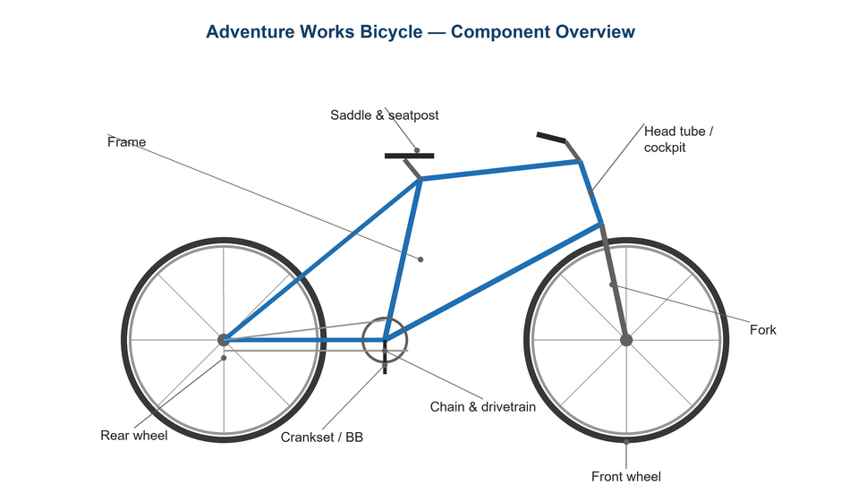
Figure 1. Pedals thread into the crank arms at the bottom bracket.

Likely Causes
- Dry pedal threads creaking against the crank.
- Loose pedal that wasn't torqued in.
- Worn cleats causing inconsistent engagement.
- Cleat bolts loosened on the shoe.
- Worn pedal bearings with play.
Safety first
- Remember the left pedal is reverse (left-hand) threaded — turn it the 'wrong' way to remove.
- A loose pedal can damage the crank threads; torque to spec.
- Practice clipping out at a wall before riding clipless in traffic.

Customer Fix — Step by Step
Suitable for home repair with basic tools. Work through the steps in order.
- Rock each pedal by hand to feel for bearing play, and listen for a creak as you pedal under load.
- Remove both pedals (left is reverse-threaded), clean and grease the threads, and reinstall to spec.
- Check cleat bolts on the shoe and tighten any that have loosened; align cleats to your natural foot angle.
- If engagement is poor, inspect cleats for wear and replace worn cleats.
- Adjust clipless release tension (spring screw) lighter for easier exit while learning.
- Test that pedals spin freely without play and engage/release cleanly.

Technician Reference
Additional checks and adjustments for service technicians and advanced users.
- Service or replace pedal bearings if there is play or roughness after greasing the threads.
- Confirm cleat shims/wedges if the rider has a leg-length or alignment need.
- Check crank thread condition; chase damaged threads or replace the crank arm if stripped.
- Match cleat type to pedal (e.g., SPD vs SPD-SL) and set float to rider preference.
- Verify Q-factor and pedal washer use on cranks that require them.

Torque & Specifications
Fastener / setting | Specification
Pedal into crank | 35 N·m
Cleat bolts | 5 – 6 N·m
Left pedal thread | Reverse (LH)
Release tension | Lighter for beginners
Bearing play | None permitted

Figure 2. Greased, correctly torqued pedal threads eliminate most pedal creaks.
Pro tips
- A tiny amount of grease on cleat bolts stops the most common 'pedal' creak — which is often the cleat.
- Replace cleats before they're badly worn to keep release predictable.

When to Visit a Service Center
- Pedal bearings are worn and the pedal isn't user-serviceable.
- Crank threads are stripped or cross-threaded.
- Persistent knee pain suggests a professional bike fit.
- Clip-in/out remains inconsistent after new cleats.
This guide is provided for reference. Torque values are typical starting points — always follow the specific component manufacturer's instructions. © Adventure Works.

